Title
Helium ions at the Heidelberg Ion Therapy Center: From measurements to Monte-Carlo Treatment Planning

Authors
T. Tessonnier (1,2), S. Brons (3), F. Cerutti (4), J. Debus (1,3), A. Ferrari (4), T. Haberer (1,3), A. Mairani (3,5), K. Parodi (2,3), P. Sala (4,6)

1 Hospital University of Heidelberg, Department of Radiation Oncology, Heidelberg, Germany
2 Ludwig-Maximilians-Universität München, Department of Medical Physics, Munich, Germany
3 Heidelberg Ion Beam Therapy Center, HIT, Heidelberg, Germany
4 European Organization for Nuclear Research, CERN, Geneva, Switzerland
5 Centro Nazionale di Adroterapia Oncologica, CNAO, Pavia, Italy
6 Istituto Nazionale di Fisica Nucleare, Sezione di Milano, INFN, Milano, Italy

Introduction: At the Heidelberg Ion beam Therapy Center (HIT), besides the clinically used protons and carbon ions, helium ions are available for research purposes. Despite the discontinuation of their use after the end of the clinical experience at the Berkeley National Laboratory in 1992, several Monte Carlo- (MC) [1], analytical- [2] or experimental-based studies [3] show that helium ions may be good candidates for further particle therapy improvement. We present in this work the experimental validation of the MC FLUKA code [4,5] predictions and the first steps of the physical validation of a research MC treatment planning tool (MCTP) [6] for helium ions at HIT.

Methods: Laterally integrated depth-dose distributions (DDD) of pencil-like helium beams have been measured using a water column, for 10 different energies in the therapeutic range. Lateral dose profiles were investigated at several depths in water, at low, middle and high beam energies. The measurements have been performed in a water tank coupled with 24 motor-driven PinPoint ionization chambers and by delivering a vertically scanned beam. Results were compared to MC-FLUKA dose predictions using the HIT beamline geometry and optimized input parameters (water ionization potential, momentum spread).
Physically-optimized spread-out Bragg peaks (SOBPs) of several sizes (3x3x3 and 6x6x6 cm³) were planned with the MCTP, using the previously experimentally-validated MC input parameters, at different depths (5, 12.5, 20 cm). A biologically-optimized SOBP was also planned by integrating a data-driven biological model to the MCTP [7,8]. Depth and lateral dose distributions of these plans were verified in the previously described water phantom.
MCTP was used for the dose calculation of a meningioma case using helium ions and was compared to protons in term of dose volume histogram (DVH).

Results: DDD measurements and MC calculations show good agreements with weighted dose differences from 0.5% to 2.3% and range differences <0.2 mm. Lateral profiles and simulations exhibit differences in FWHM below 8%.
Physically- and biologically-optimized simulated SOBPs show good agreements with measurements with dose differences below 3% for both depth and lateral dose profiles. The homogeneity inside the physically-optimized SOBPs is below 5%.
For the clinical case, the DVH analysis shows advantages of helium ions compared to protons, including a sharper slope (better homogeneity) for the target and a better sparing of the organ at risk.
Conclusion: The satisfactory results between MC-FLUKA predictions and MCTP-optimized plans against measurements suggest that the FLUKA code, and its research MCTP extension, offer a promising research engine for further investigations and planning studies comparisons between helium ions and the clinically used protons and carbon ions towards eventual clinical deployment.
We acknowledge funding from DFG (KFO Schwerionentherapie 214).

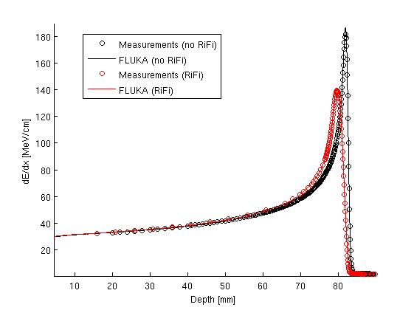
Figure 1: Depth dose distribution for 4He with and without Ripple Filter (RiFi) (initial energy beam of 103.05 MeV/u): MC-FLUKA predictions (lines) against experimental measurements (circles).

[1] Burigo et al., “Comparative study of dose distributions and cell survival fractions for 1h, 4he, 12c and 16o beams using geant4 and microdosimetric kinetic model”, PMB 2015
[2] Grun et al., “Assessment of potential advantages of relevant ions for particle therapy: A model based study”, Med Phys 2015
[3] Tessonnier et al., “Experimental dosimetric comparisons at Heidelberg ion beam therapy center of 1h, 4he, 12c and 16o ion beams”, Physica Medica 2015
[4] Ferrari et al., “FLUKA: a multi-particle transport code”, Technical Report CERN 2005
[5] Böhlen et al.,“The FLUKA code: Developments and challenges for high energy and medical applications”, Nuclear Data Sheets 2014
[6] Böhlen et al.,“A monte carlo-based treatment planning tool for ion beam therapy”, JRS 2013
[7] Mairani et al., “Data-driven RBE parametrization for helium ion beams”, PMB 2016
[8] Mairani et al., “Biologically optimized helium ion plans: calculation approach and its in vitro validation”, submitted to PMB 2016

