Title
Helium ions at the Heidelberg Ion Therapy Center: From measurements to Monte-Carlo Treatment Planning

Authors
T. Tessonnier (1,2), S. Brons (3), F. Cerutti (4), J. Debus (1,3), A. Ferrari (4), T. Haberer (1,3), A. Mairani (3,5), K. Parodi (2,3), P. Sala (4,6)

1 Hospital University of Heidelberg, Department of Radiation Oncology, Heidelberg, Germany
2 Ludwig Maximilians University, Department of Medical Physics, Munich, Germany
3 Heidelberg Ion Beam Therapy Center, HIT, Heidelberg, Germany
4 European Organization for Nuclear Research, CERN, Geneva, Switzerland
5 Centro Nazionale di Adroterapia Oncologica, CNAO, Pavia, Italy
6 Istituto Nazionale di Fisica Nucleare, Sezione di Milano, INFN, Milano, Italy

Introduction: At the Heidelberg Ion beam Therapy Center (HIT), besides the clinically used protons and carbon ions, helium ions are available for research purposes. Despite the discontinuation of their use after the end of the clinical experience at the Berkeley National Laboratory in 1992, several Monte Carlo- (MC), analytically- or experimentally-based studies show that helium ions may be good candidates for further particle therapy improvement. We present in this work the experimental validation of the MC FLUKA code predictions and the first steps of the physical validation of the MC treatment planning tool (MCTP) for helium ions at HIT.

Methods: Laterally integrated depth-dose distributions (DDD) of pencil-like helium beams have been measured using a water column, for 10 different energies in the therapeutic. Lateral dose profiles were investigated at several depths in water, at low, middle and high beam energies. The measurements have been performed in a water tank coupled with 24 motor-driven PinPoint ionization chambers and by delivering a vertically scanned beam. Results were compared to MC-FLUKA dose predictions using the HIT beamline geometry and optimized parameters (ionization potential, momentum spread).
Physically-optimized spread-out Bragg peaks (SOBPs) of several sizes (3x3x3 and 6x6x6 cm³) were planned with the MCTP, using the previously experimentally-validated parameters, at different depths (5, 12.5, 20 cm). A biologically-optimized SOBP was planned by integrating a data-driven biological model to the MCTP. Depth and lateral dose distributions of these plans were verified in the previously described water phantom.
MCTP was used for the dose calculation of a meningioma case using helium ions and was compared to protons in term of dose volume histogram (DVH).

Results: DDD measurements and MC calculations show good agreements with weighted dose differences from 0.5% to 2.3% and range differences <0.2 mm. Lateral profiles and simulations exhibit differences in FWHM below 8%.
Physically- and biologically-optimized simulated SOBPs show good agreements with measurements with dose differences <3% for both depth and lateral dose profiles. The homogeneity inside the physically-optimized SOBPs is below <5%.
For the clinical case, the target DVH is more favorable with helium ions than with protons, with a sharper slope (better homogeneity) and better sparing of the organs at risk.

Conclusion: The satisfactory results between MC-FLUKA predictions and plans against measurements suggest that the FLUKA-MCTP is a promising research planning engine for helium ions at HIT. Future investigations and planning studies should further compare helium ions with the clinically used protons and carbon ions.
We acknowledge funding from DFG (KFO Schwerionentherapie 214).

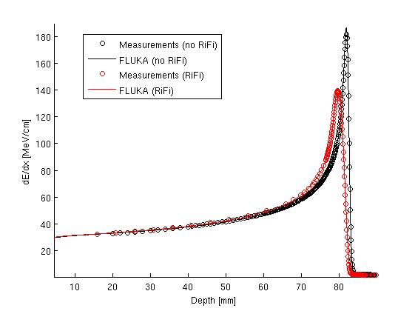

Figure 1: Depth dose distribution for 4He with and without Ripple Filter (RiFi) (initial energy beam of 103.05 MeV/u): MC-FLUKA predictions (lines) against experimental measurements (circles).

