Title: Quantitative performance of a Signa PET/MR based on the NEMA NU 2-2007 standard

Authors:
J-A. Maisonobe (1), M. Soret (1), A. Kas (1).
1 Groupe Hospitalier Pitié-Salpêtrière – Nuclear Medicine Department/Paris/France

Introduction: Our purpose was to assess the quantitative performance of a Signa PET/MR (GE Healthcare), which combines both TOF measurement and a 3T MRI.

Methods: The performance of a Signa PET/MR was evaluated based on the NEMA NU 2-2007 [1]. Analyses were performed with the manufacturer’s software.
To characterize the image quality, the contrast activity between the 4 smallest spheres and the background was 4. The 2 biggest spheres were filled with non-radioactive water. A 10mn acquisition was performed and the image was reconstructed with a 3D iterative TOF algorithm, without PSF. The recovery coefficient (RC) and the background variability (BV) of the spheres were calculated.
The measurement of the spatial resolution was done using 3 point sources located in a transaxial plane, in the middle of the axial field-of-view (FOV), and shifted of 6.3cm. The images were reconstructed with FBP. The Full Width at Half Maximum (FWHM) and the Full Width at Tenth Maximum (FWTM) of the sources in the axial and transverse directions were measured.
The sensitivity was measured with different acquisitions of a 70cm line source, containing 9MBq and placed in differing amount of attenuation material. It was centered in the transverse FOV and then shifted of 10cm. The sensitivity was deducted dividing the extrapolated count rate without attenuation by the measured activity.
Finally, the count rate and the scatter fraction (SF) were measured during 14 hours thanks to a line source containing 830MBq. The curves obtained (cf figure) allowed us to determine the activity concentration at maximum of NECR as well as the SF.

Results: The RC(%) and BV(%) for the 10, 13, 17, 22, 28 and 37mm diameters spheres were 62.0-71.8-108.1-96.0-86.7-91.1 and 7.1-5.4-4.0-3.2-2.5 and 2.1, respectively.
The mean FWHM/FWTM (in mm) of the punctual sources located at 1 and 10cm from the central axis were 4.02/8.57 and 5.08/9.68 in transverse, and 5.70/11.40 and 7.41/14.70 in axial. The sensitivity in the centre of the FOV and at 10cm were 23.5 and 22.8cps/kBq. The activity concentration at maximum of NECR was 223kcps for an activity concentration of 18.9kBq/mL. This value was associated to a SF of 44.06%.

Conclusions: The performances of the Signa PET/MR were better than the manufacturer specifications. However, the image quality was not performed with an attenuation correction image obtained with the MRI but on a theoretical density phantom one. The characterization of this parameter does not allow for an evaluation of the quality of the attenuation correction provided by the MRI.

References:
[1] National Electrical Manufacturers Association. Performance measurements of positron emission tomographs. NEMA Standards Publication NU 2-2007. 2007.

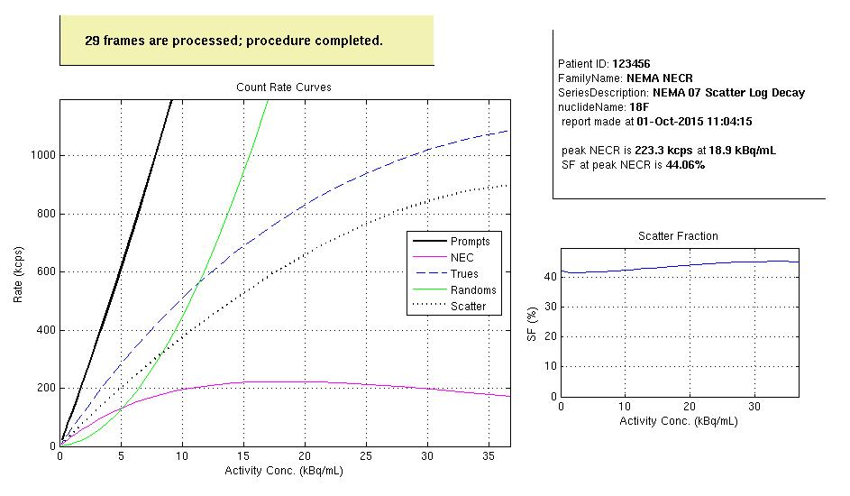
Figure: Count rate analysis result

