Intra cranial hypo-fractionated radiotherapy end-to-end QA.

R. Garcia, E. Jaegle, V. Bodez, C. Khamphan, M.E. Alayrach, A. Badey, P. Martinez.
Institut Sainte Catherine, Avignon

Introduction :
Intra cranial hypo-fractionated radiotherapy concerns small targets which need a complex delivery to optimize the dose distribution. Current techniques combine multiple arcs and intensity modulated beams. Such very precise irradiations need an efficient dosimetric validation.
Many detectors enable the comparison between the calculation and the irradiation. They are variably efficient to get a real proof of a good match. We investigated dosimetric validations from 2D detector to 3D anthropomorphic configurations.

Material and Methods :
A patient head Dicom CT image files were sent to Rt-Safe company. They 3D-printed the head with a plastic material and filled the brain cavity with an MRI dosimetric gel. The head phantom was placed in the same patient position using the original immobilization devices. The patient plan was imported in the head phantom CT-data to be calculated and then to deliver the irradiation. An MRI acquisition of the head phantom was obtained with a specific configuration. The MRI Dicom file was used to provide a 3D measured dose distribution.
The same plan was used with the portal dosimetry PDIP/Varian and the Delta4/Scandidos phantom.
The three dosimetric systems provided profiles comparisons and gamma index evaluations.

Results :
The measurements and analyses concern a very small target which PTV diameter is 1cm. The profiles comparisons show a perfect matching with the Delta4 system. The PDIP measurement is slightly compromised with the continuous detector position face to the beam. The gel dosimetry contains uncertainties linked to the complex process and particularly to the MRI acquisition.
Delta4 and MRI-gel display respectively a percentage of gamma index passing 3%/3mm tolerances, of 100% and 99.2 %.
Table 1 displays the results with different parameters in %, mm for a global Gamma index.
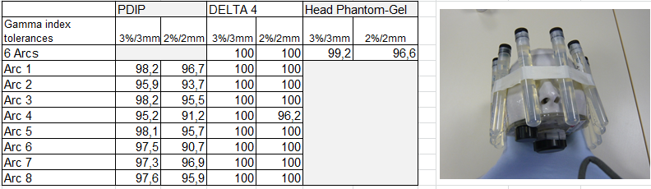

Conclusion :
The way to validate and secure an irradiation depends on its complexity.
The PDIP is well adapted to a routine check. The delta 4 gives a high level of validation but cannot be irradiated with non-coplanar beams or arcs.
Concerning the highest dose per session treatments it is relevant to rely on an end-to-end QA process based on an anthropomorphic phantom close to the real treatment conditions. The 3D-printed head and the gel dosimetry reproduce the exact patient conditions and give a fully satisfactory validation.

