Annexes

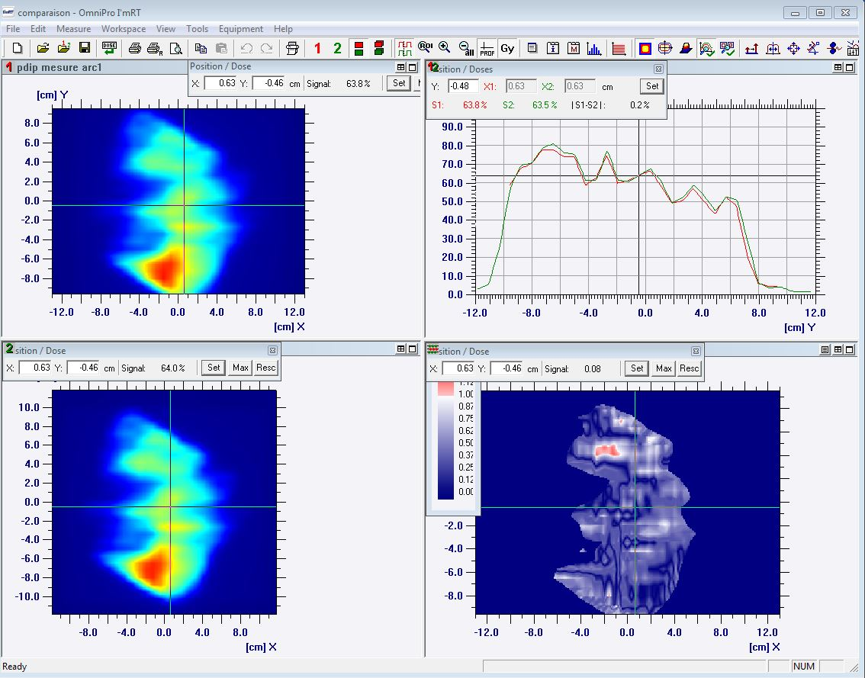
Fig.1.comparison of the accumulated signal for one arc acquired with Matrixx and with the flat panel

